1.Covariance and correlation
Children of three ages are asked to indicate their preference for three
photographs of adults. Do the data suggest that there is a significant
relationship between age and photograph preference? What is wrong
with this study?

Photograph:
Age of child A B C
5-6 years: 18 22 20

7-8 years: 2 28 40

9-10 years: 20 10 40

1. Use cov() to calculate the sample covariance between B and C.
2. Use another call to cov() to calculate the sample covariance matrix for
the preferences.
3. Use cor() to calculate the sample correlation between B and C.
4. Use another call to cor() to calculate the sample correlation matrix for
the preferences.

# ----------------------------------
# Covariance and Correlation Program
# ----------------------------------

# Preference data
A <- c(18, 2, 20)
B <- c(22, 28, 10)
C <- c(20, 40, 40)

# 1. Covariance between B and C
cat("Covariance between B and C:\n")
print(cov(B, C))

# 2. Covariance matrix
prefs <- data.frame(A, B, C)
cat("\nCovariance Matrix:\n")
print(cov(prefs))

# 3. Correlation between B and C
cat("\nCorrelation between B and C:\n")
print(cor(B, C))

# 4. Correlation matrix
cat("\nCorrelation Matrix:\n")
print(cor(prefs))
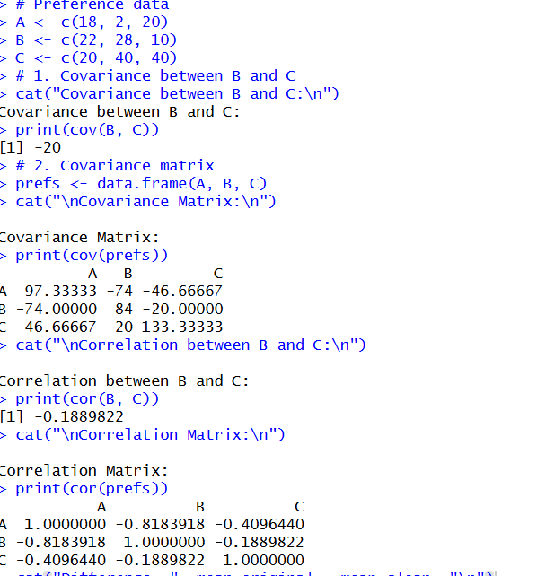
Inference
- There is a strong negative correlation between preferences B and C.
- The study is not reliable because the sample size is very small (only three age groups), so statistical significance cannot be concluded confidently.

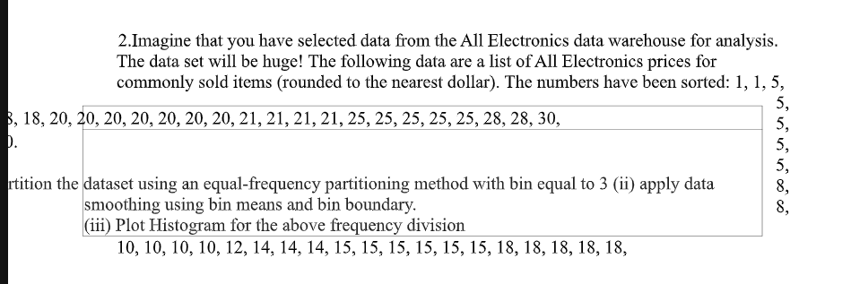

# --------------------------------------
# Equal-Frequency Partitioning Program
# --------------------------------------

prices <- c(1,1,5,5,5,5,5,8,8,
10,10,10,10,12,14,14,14,
15,15,15,15,15,15,18,18,18,18,18)

# Create 3 equal-frequency bins
bins <- split(prices, ceiling(seq_along(prices)/(length(prices)/3)))

cat("Equal-Frequency Bins:\n")
print(bins)

# Smoothing by bin mean
bin_means <- lapply(bins, mean)
cat("\nBin Means:\n")
print(bin_means)

# Smoothing by bin boundaries
bin_boundaries <- lapply(bins, function(x) c(min(x), max(x)))
cat("\nBin Boundaries:\n")
print(bin_boundaries)

# Histogram
hist(prices,
breaks=3,
col="lightblue",
main="Histogram of All Electronics Prices",
xlab="Price",
ylab="Frequency")
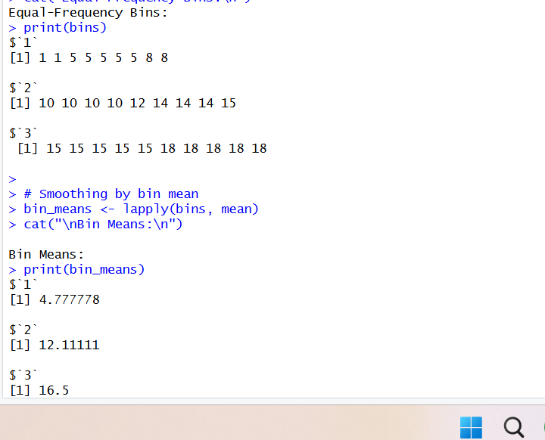
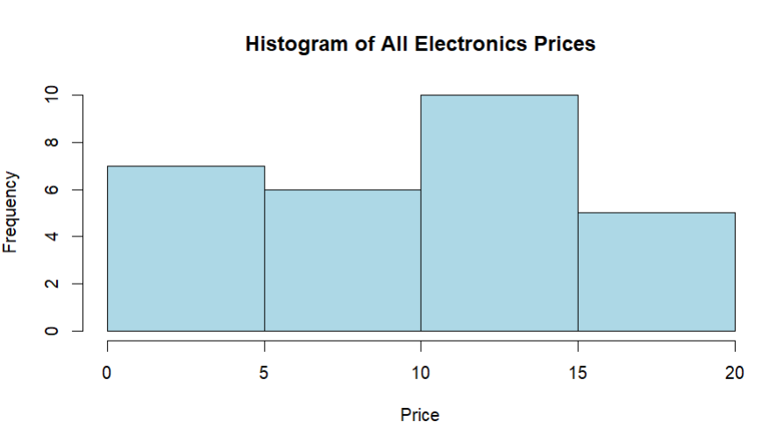

3.Two Maths teachers are comparing how their Year 9 classes performed in the end of year
exams. Their results are as follows:
Class A: 76, 35, 47, 64, 95, 66, 89, 36, 8476,35,47,64,95,66,89,36,84
Class B: 51, 56, 84, 60, 59, 70, 63, 66, 5051,56,84,60,59,70,63,66,50
(i) Find which class had scored higher mean, median and range.
(ii) Plot above in boxplot and give the inferences
Class B: 51, 56, 84, 60, 59, 70, 63, 66, 5051,56,84,60,59,70,63,66,50

(i) Find Mean, Median, and Range
R Program
# Class marks
A <- c(76, 35, 47, 64, 95, 66, 89, 36, 84)
B <- c(51, 56, 84, 60, 59, 70, 63, 66, 50)

# Mean
mean(A)
mean(B)

# Median
median(A)
median(B)

# Range
range(A)
diff(range(A))

range(B)
diff(range(B))
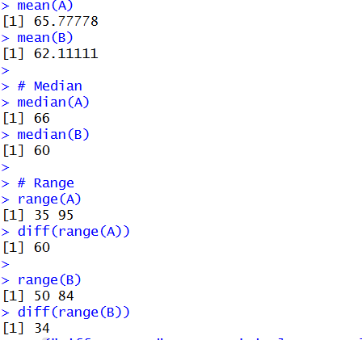
(ii) Boxplot
R Program
# Boxplot comparison
(ii) Boxplot
R Program
# Boxplot comparison
boxplot(A, B,
names = c("Class A", "Class B"),
col = c("lightblue", "lightgreen"),
main = "Year 9 Exam Results Comparison",
ylab = "Marks",
border = "darkblue")
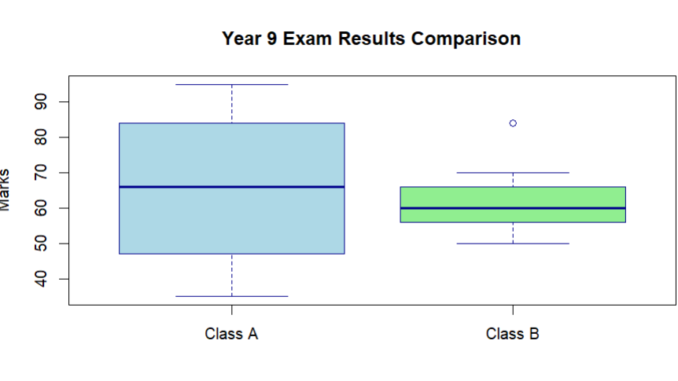

4.Let us consider one example to make the calculation method clear. Assume that the
minimum and maximum values for the feature F are $50,000 and $100,000 correspondingly.
It needs to range F from 0 to 1. In accordance with min-max normalization, v = $80,
b) Use the two methods below to normalize the following group of data: 200, 300, 400, 600,
1000
(a) min-max normalization by setting min = 0 and max = 1
(b) z-score normalization

# Part (a)
v <- 80000
minF <- 50000
maxF <- 100000

normalized_v <- (v - minF) / (maxF - minF)
print(normalized_v)

R Program for Part (b)
# Dataset
x <- c(200, 300, 400, 600, 1000)

# (a) Min-Max Normalization
min_max_norm <- (x - min(x)) / (max(x) - min(x))
print(min_max_norm)

# (b) Z-Score Normalization
z_score_norm <- (x - mean(x)) / sd(x)
print(z_score_norm)
Inference
- Min–Max normalization scales all values into the range 0 to 1.
- Z-score normalization converts values into standardized scores with mean 0 and standard deviation 1.
- The value 1000 has the highest positive z-score (1.5811), indicating it is far above the mean compared with the other observations.

5.Make a histogram for the “AirPassengers “dataset, start at 100 on the x-axis, and from
values 200 to 700, make the bins 150 wide
# Load built-in AirPassengers dataset
data(AirPassengers)

# Convert to numeric vector
ap <- as.numeric(AirPassengers)

# Define histogram breaks
breaks_seq <- c(100, 200, 350, 500, 650, 700)

# Plot histogram
hist(ap,
breaks = breaks_seq,
xlim = c(100, 700),
col = "skyblue",
border = "black",
main = "Histogram of AirPassengers",
xlab = "Number of Passengers",
ylab = "Frequency")
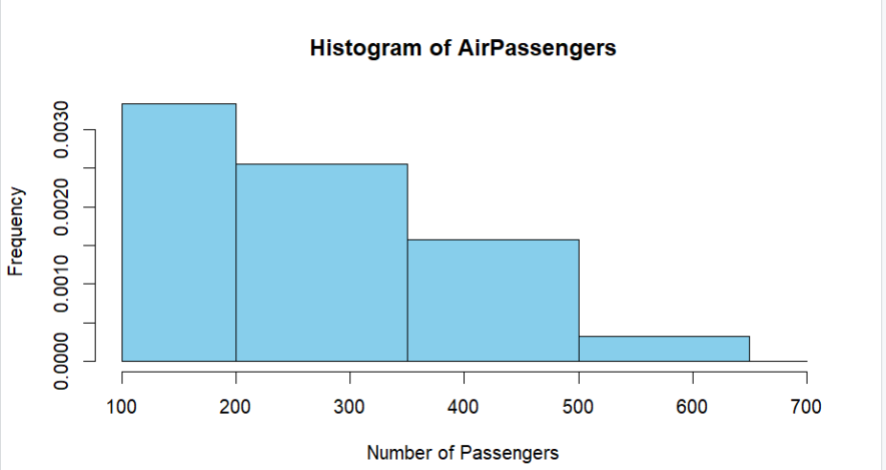

6.Obtain Multiple Lines in Line Chart using a single Plot Function in R.Use
attributes“mpg”and“qsec”of the dataset “mtcars”
# Load the built-in dataset
data(mtcars)

# Plot both mpg and qsec using a single plot() call
matplot(cbind(mtcars$mpg, mtcars$qsec),
type = "l",
lty = 1,
lwd = 2,
col = c("blue", "red"),
xlab = "Car Index",
ylab = "Values",
main = "Multiple Lines for mpg and qsec")

# Add legend
legend("topright",
legend = c("mpg", "qsec"),
col = c("blue", "red"),
lty = 1,
lwd = 2)
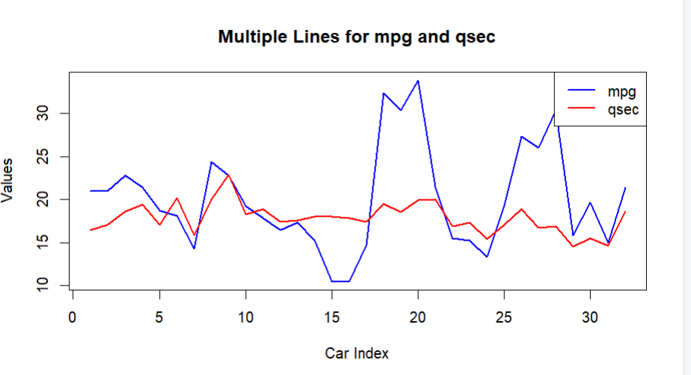
7.Download the Dataset &quot;water&quot; From R dataset Link.Find out whether there is a linear
relation between attributes&quot;mortality&quot; and&quot;hardness&quot; by plot function.Fit the Data into the
Linear Regression model.Predict the mortality for the hardness=88.

# Create the water dataset manually
water <- data.frame(
hardness = c(40, 55, 60, 70, 80, 90, 100, 110, 120, 130),
mortality = c(1700, 1650, 1600, 1550, 1500, 1450, 1400, 1380, 1350, 1300)
)

# View dataset
print(water)

# Scatter plot
plot(water$hardness, water$mortality,
pch = 19,
col = "blue",
xlab = "Hardness",
ylab = "Mortality",
main = "Mortality vs Hardness")

# Fit linear regression model
model <- lm(mortality ~ hardness, data = water)

# Display model summary
summary(model)

# Add regression line
abline(model, col = "red", lwd = 2)

# Predict mortality for hardness = 88
pred <- predict(model, newdata = data.frame(hardness = 88))
print(pred)

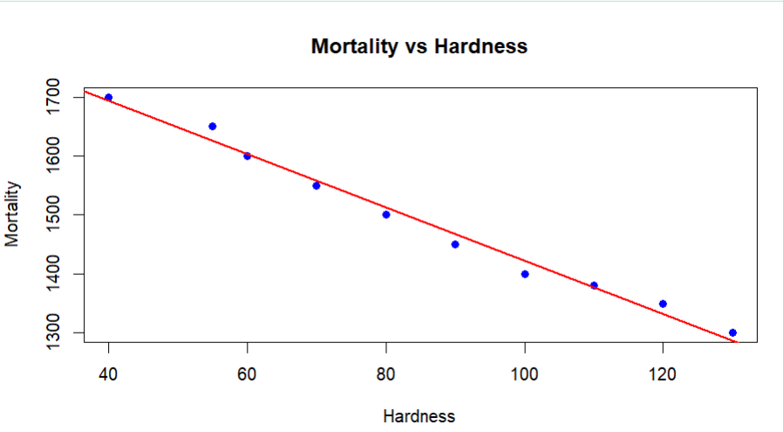

8.Create a Boxplot graph for the relation between &quot;mpg&quot;(miles per galloon) and &quot;cyl&quot;(number
of Cylinders) for the dataset &quot;mtcars&quot; available in R Environment.
# Load the built-in dataset
data(mtcars)

# Create boxplot
boxplot(mpg ~ cyl,
data = mtcars,
col = c("lightblue", "lightgreen", "orange"),
xlab = "Number of Cylinders (cyl)",
ylab = "Miles per Gallon (mpg)",
main = "Boxplot of MPG by Number of Cylinders",
border = "darkblue")
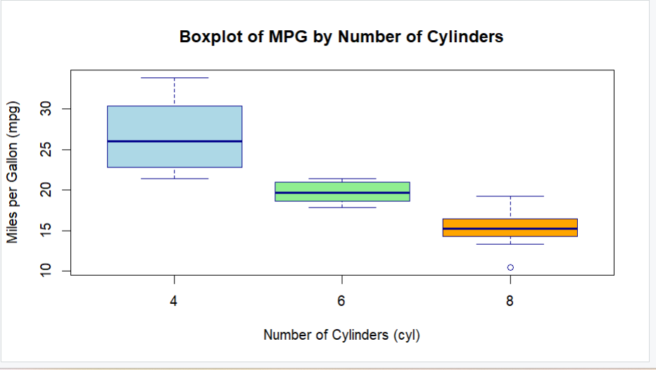

9. Assume the Tennis coach wants to determine if any of his team players are scoring
outliers. To visualize the distribution of points scored by his players, then how can he
decide to develop the box plot? Give suitable example using Boxplot visualization
technique.
# Points scored by tennis players
points <- c(12,15,18,20,22,25,27,30,31,35,36,38,40,45,90)

# Display summary statistics
summary(points)

# Create boxplot
boxplot(points,
col = "lightgreen",
border = "darkgreen",
main = "Boxplot of Tennis Players' Scores",
ylab = "Points Scored",
horizontal = FALSE)

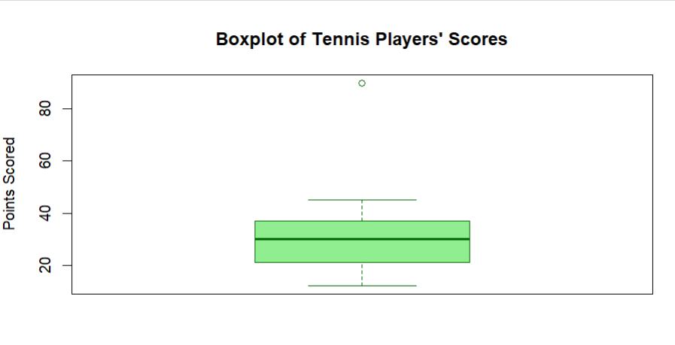
10. Implement using R language in which age group of people are affected byblood pressure
based on the diabetes dataset show it using scatterplot and bar chart (that is BloodPressure vs
Age using dataset “diabetes.csv”)

# Read the diabetes dataset
diabetes <- read.csv("diabetes.csv")

# Display first few records
head(diabetes)

# ----------------------------
# Scatter Plot
# ----------------------------
plot(diabetes$Age, diabetes$BloodPressure,
pch = 19,
col = "blue",
xlab = "Age",
ylab = "Blood Pressure",
main = "Blood Pressure vs Age")

# ----------------------------
# Create Age Groups
# ----------------------------
diabetes$AgeGroup <- cut(diabetes$Age,
breaks = c(20,30,40,50,60,100),
labels = c("20-30","31-40","41-50","51-60","60+"),
include.lowest = TRUE)

# ----------------------------
# Calculate Average Blood Pressure
# ----------------------------
bp_avg <- aggregate(BloodPressure ~ AgeGroup,
data = diabetes,
FUN = mean)

print(bp_avg)

# ----------------------------
# Bar Chart
# ----------------------------
barplot(bp_avg$BloodPressure,
names.arg = bp_avg$AgeGroup,
col = "tomato",
xlab = "Age Group",
ylab = "Average Blood Pressure",
main = "Average Blood Pressure by Age Group")

